**Build an Event Management System using Salesforce**

1. **INTRODUCTION:**
   1. **OVERVIEW**

* Event management is the process of creating and maintaining an event. This process spans from the very beginning of planning all the way to post-event strategizing.
* At the start, an event manager makes planning decisions, such as the time, location, and theme of their event. During an event, event managers oversee the event live and make sure things run smoothly. After an event, event managers are tasked with reviewing event data, submitting KPI and ROI findings, and staying on the ball for any post-event offerings.
  1. **PURPOSE**
* Real Time Salesforce Project
* Object & Relationship in Salesforce
* Create Salesforce Org:
* An Event Management System minimizes the steps needed to manage your events, creating a much more efficient administrative process.
* This way, event planners can focus more on the details, without getting lost in administrative tasks.
* An Event Management System (or Event Management Software) helps organizers plan, execute and report on events, driving success for their business.

1. **PROBLEM DEFINTION AND DESIGN THINKING** 
   1. **EMPATHY MAP**

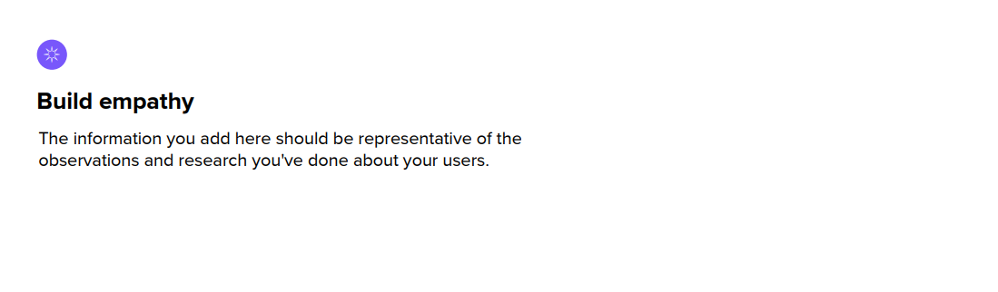

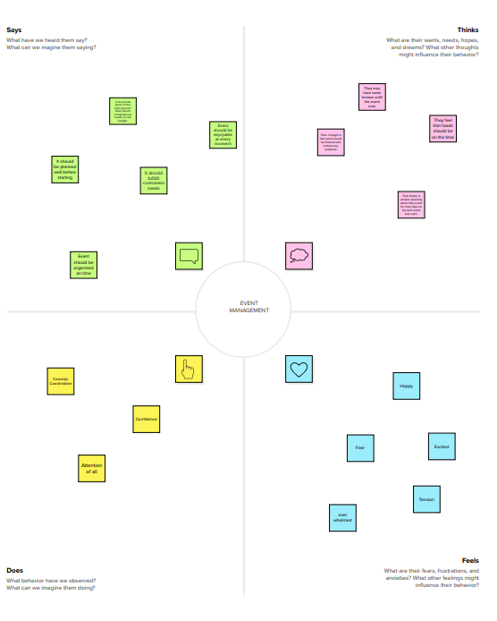

* 1. **IDEATION AND BRAIN STORMING MAP**

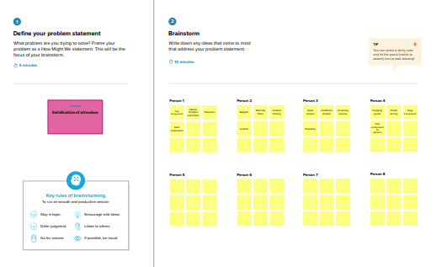

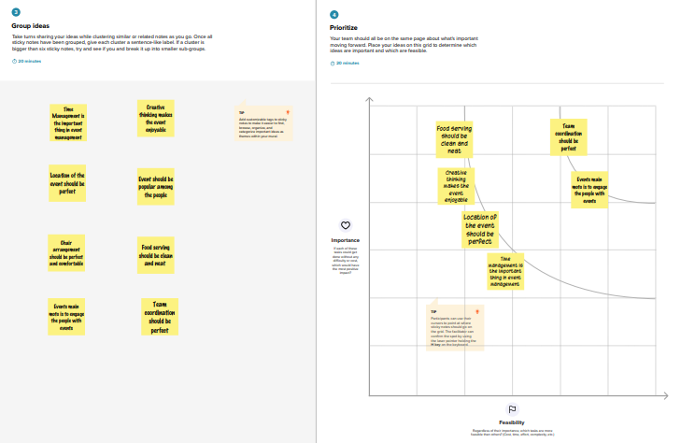

1. **RESULT**
   1. **DATA MODEL**

|  |  |
| --- | --- |
| **Object Name** | **Fields in the Object** |
| **Event** | |  |  | | --- | --- | | **Field label** | **Data Type** | | **City** | **Text** | | **Start date** | **Date/Time** | | **End date** | **Date/Time** | | **Event Name** | **Master – detail Relationship** | |
| **Attendee** | |  |  | | --- | --- | | **Field label** | **Data Type** | | **enter Id** | **Auto number** | | **Phone** | **Phone** | | **Email** | **Email** | |
| **Speaker** | |  |  | | --- | --- | | **Field label** | **Data Type** | | **Bio** | **Text Area** | | **e-mail** | **Email** | | **Event Name** | **Look-up relationship** | |
| **Vendor** | |  |  | | --- | --- | | **Field label** | **Data Type** | | **e-mail** | **Email** | | **Phone** | **Phone** | | **Service Provider** | **Text** | | **Event Name** | **Look-up relationship** | |

* 1. **ACTIVITY AND SCREENSHOT**

**Milestone 1 – Salesforce:**

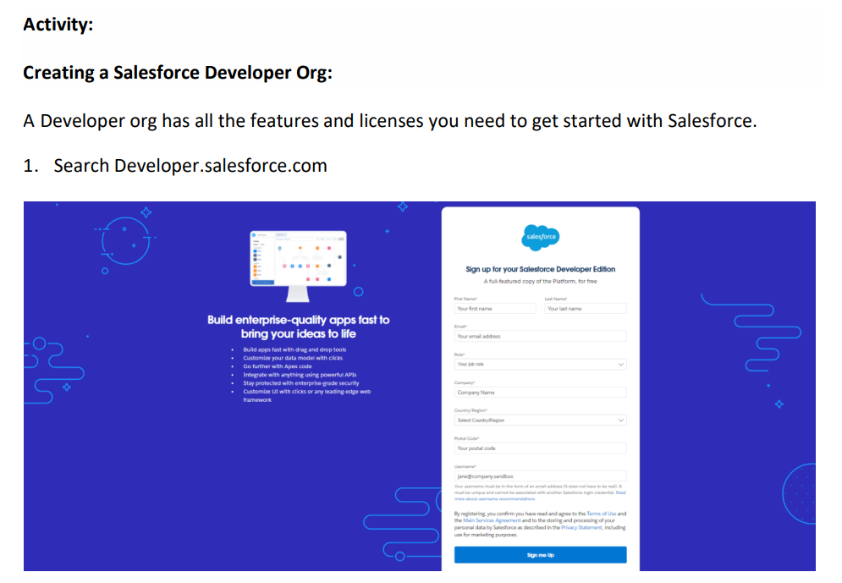

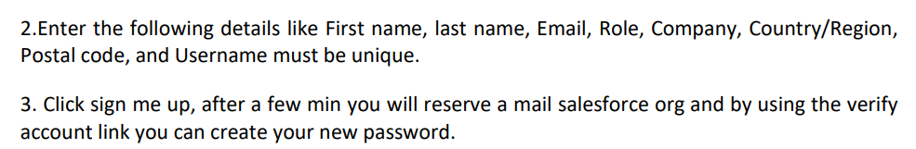

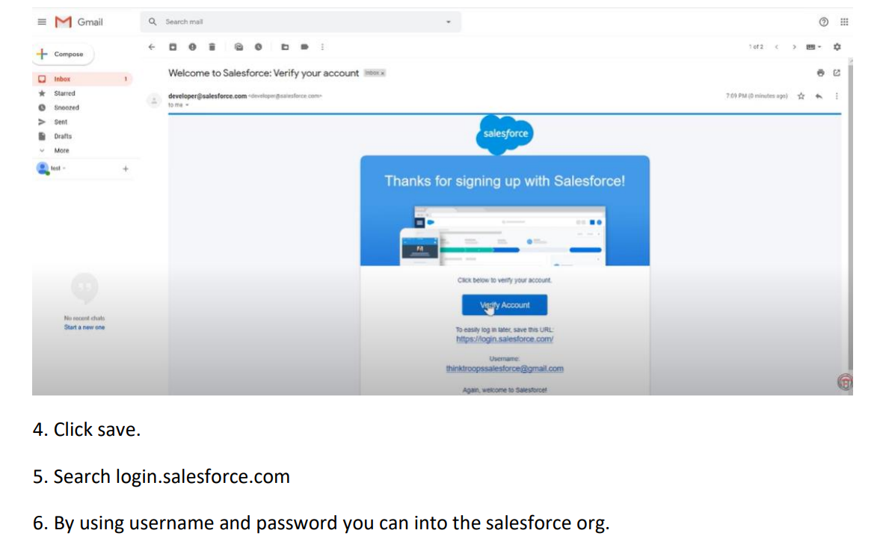

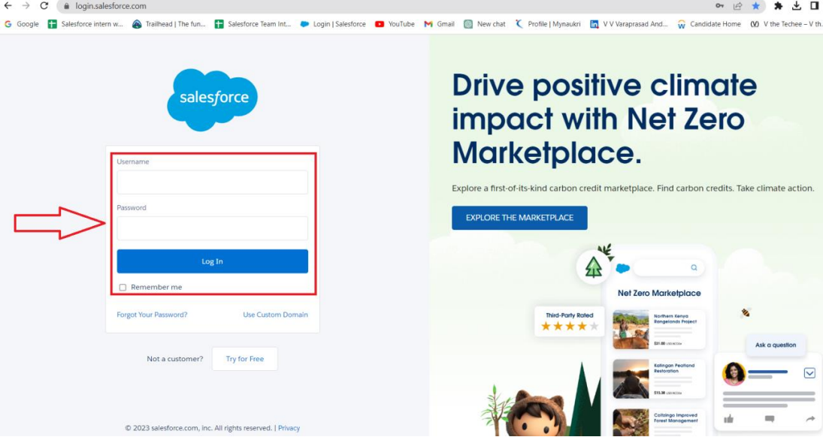



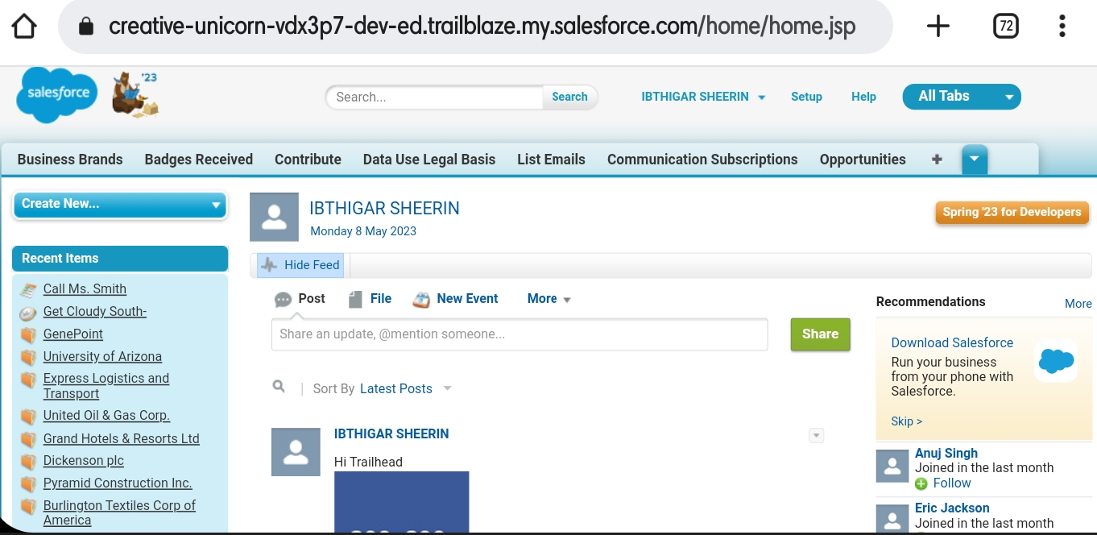

**Milestone 2 – Object:**

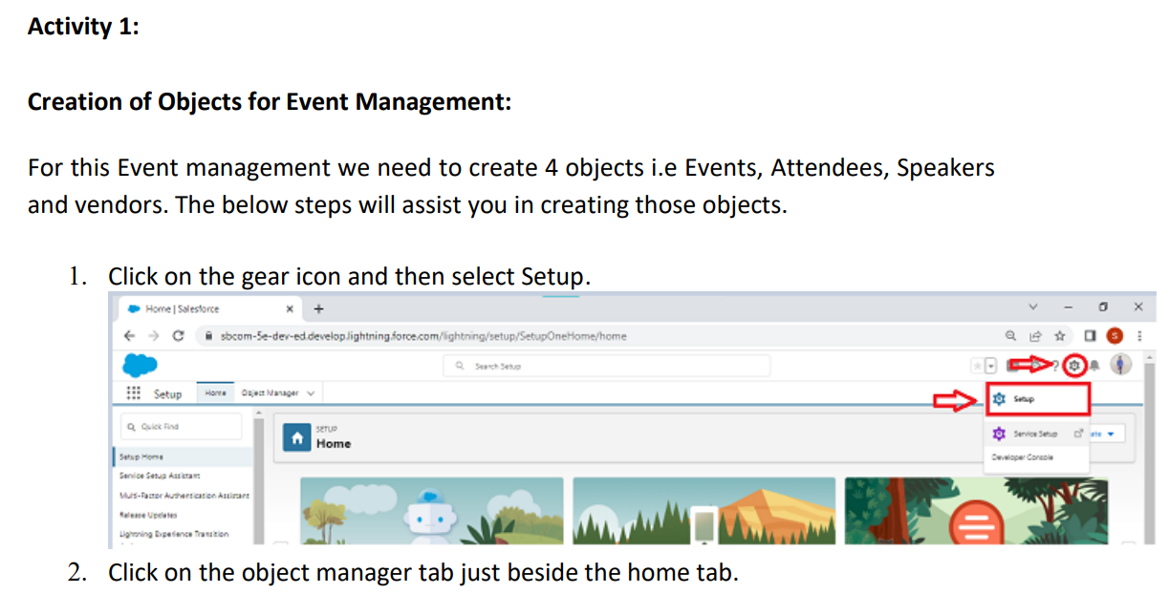

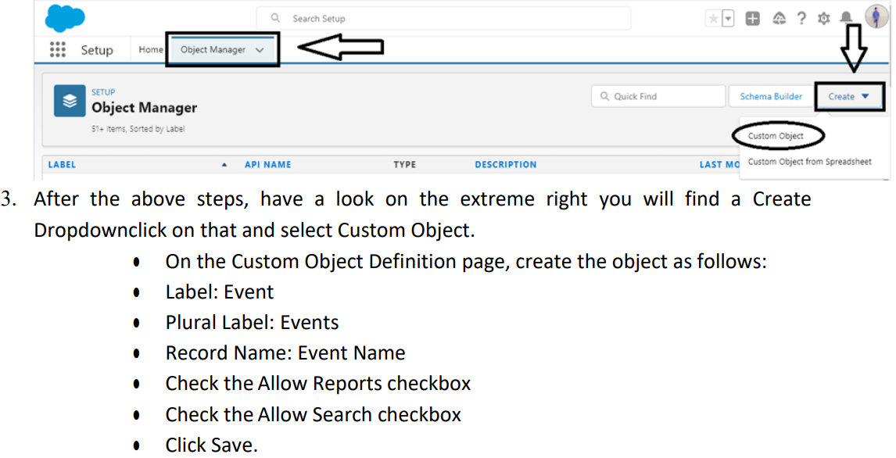

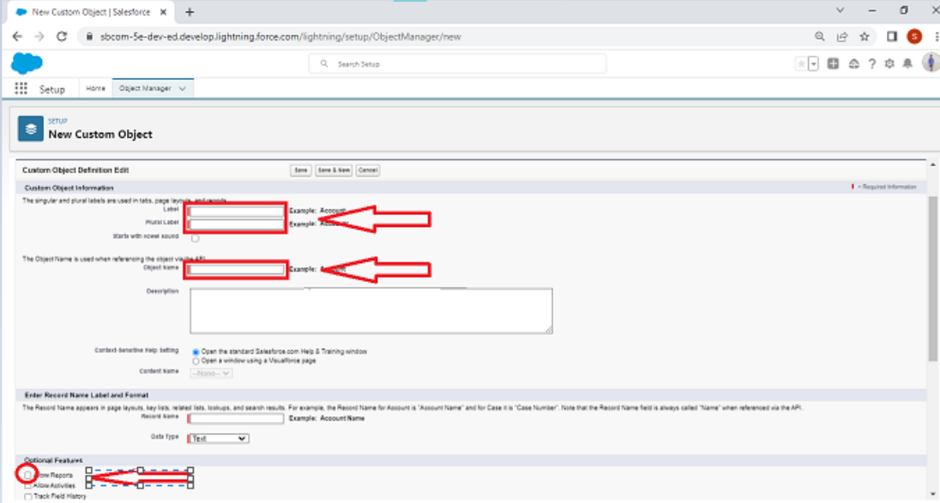

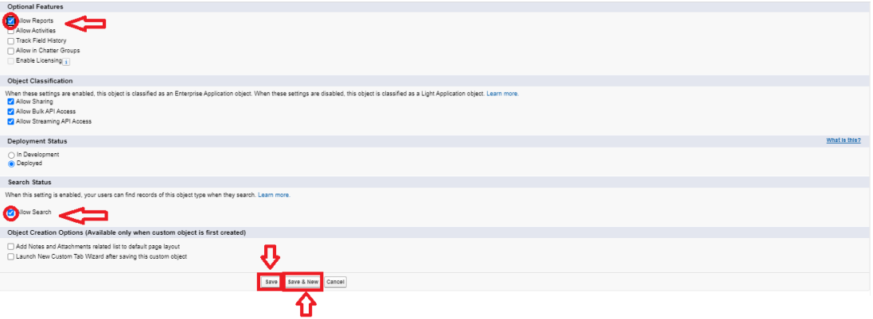

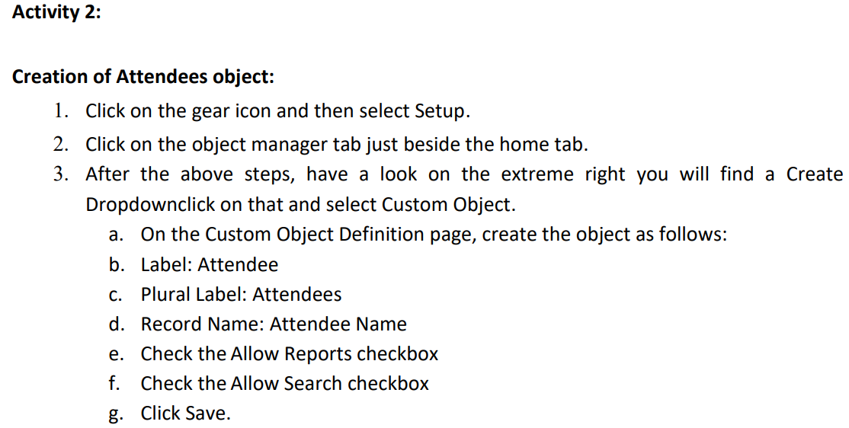

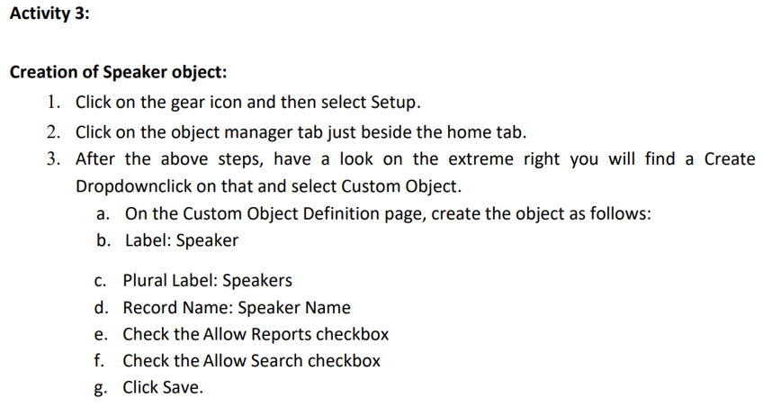

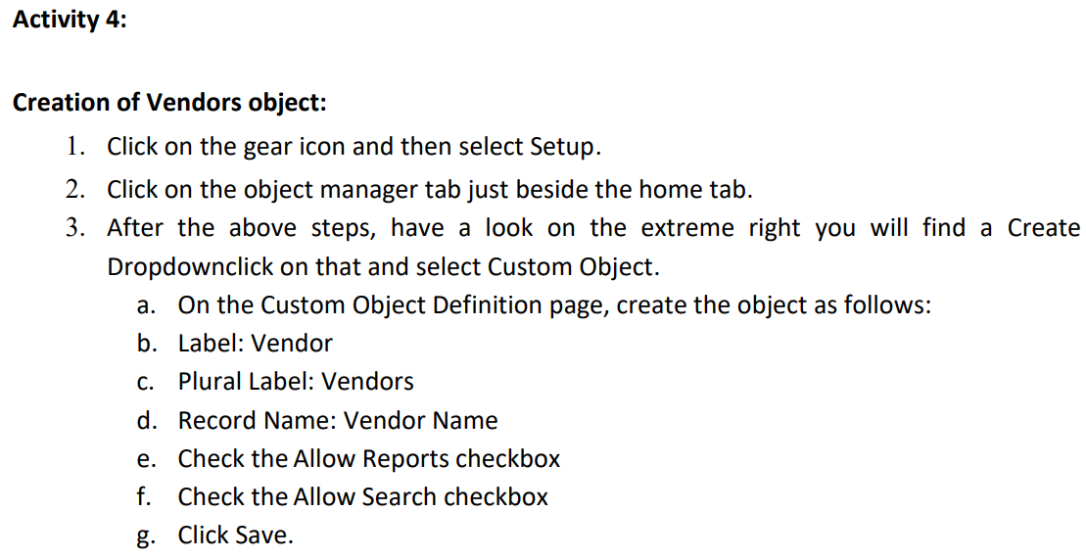

**Milestone 3 – Tab:**

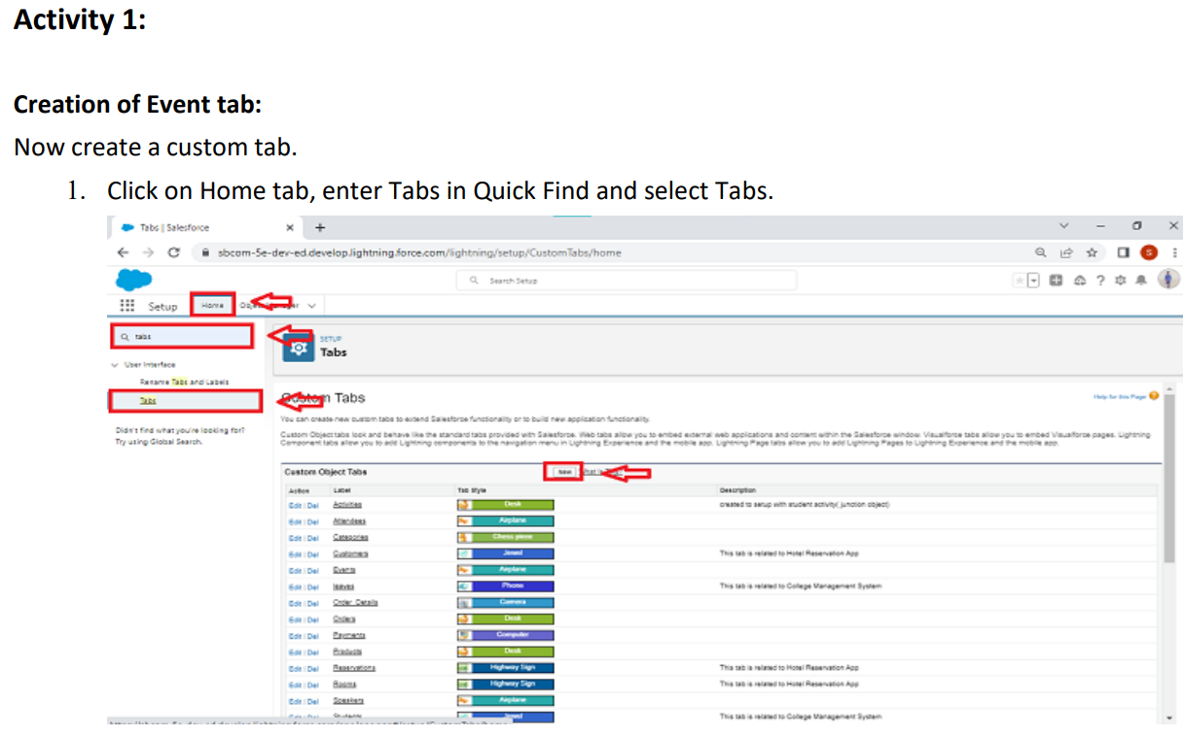

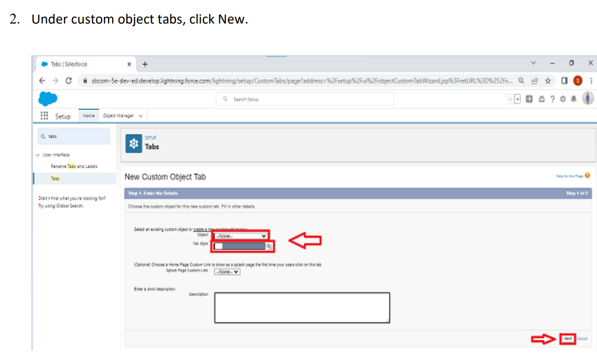

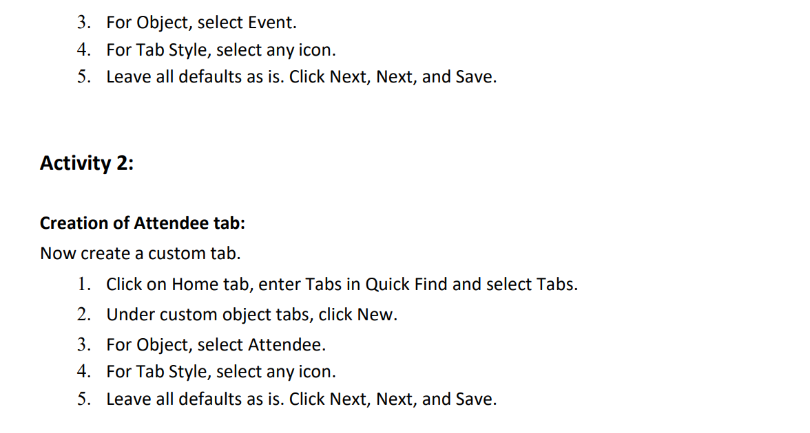

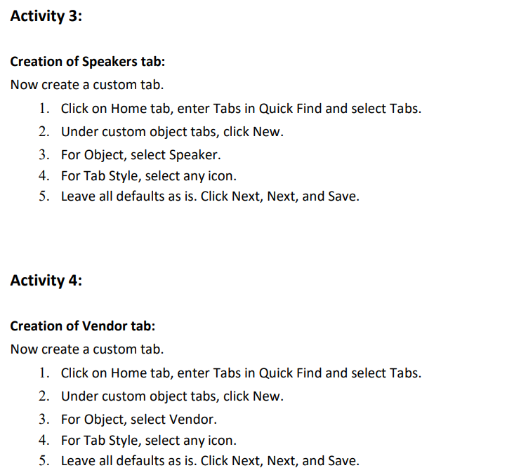

**Milestone 4 – Application:**

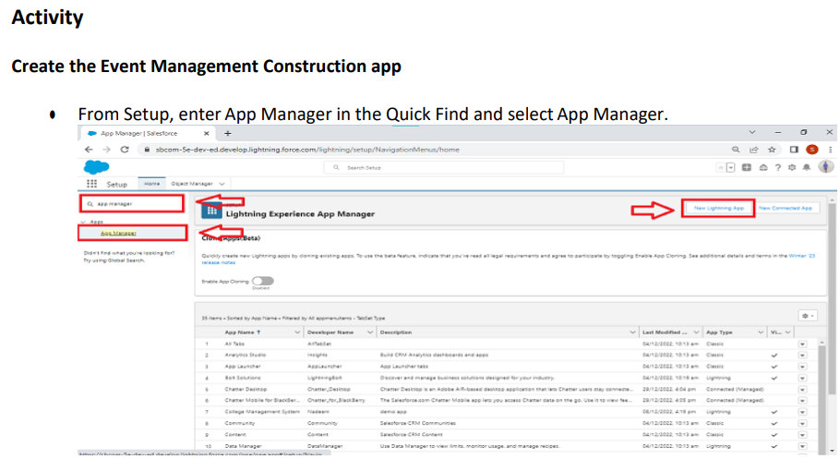

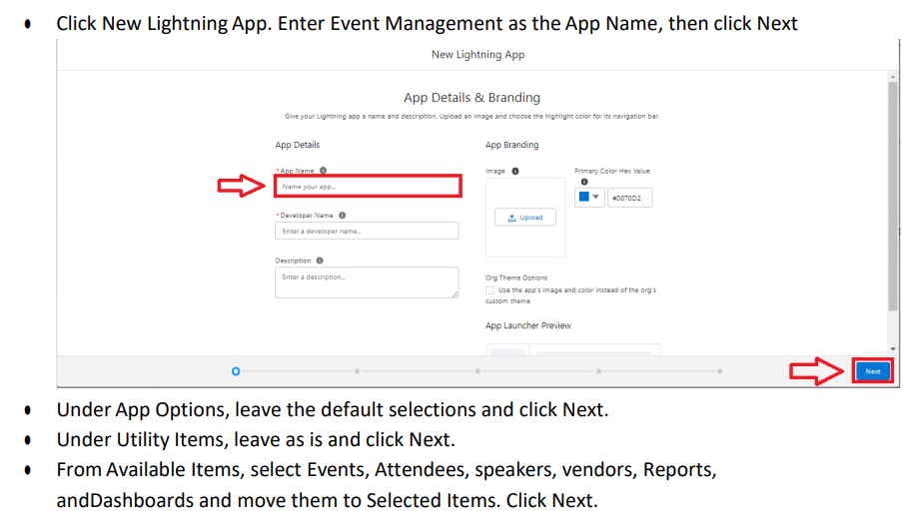

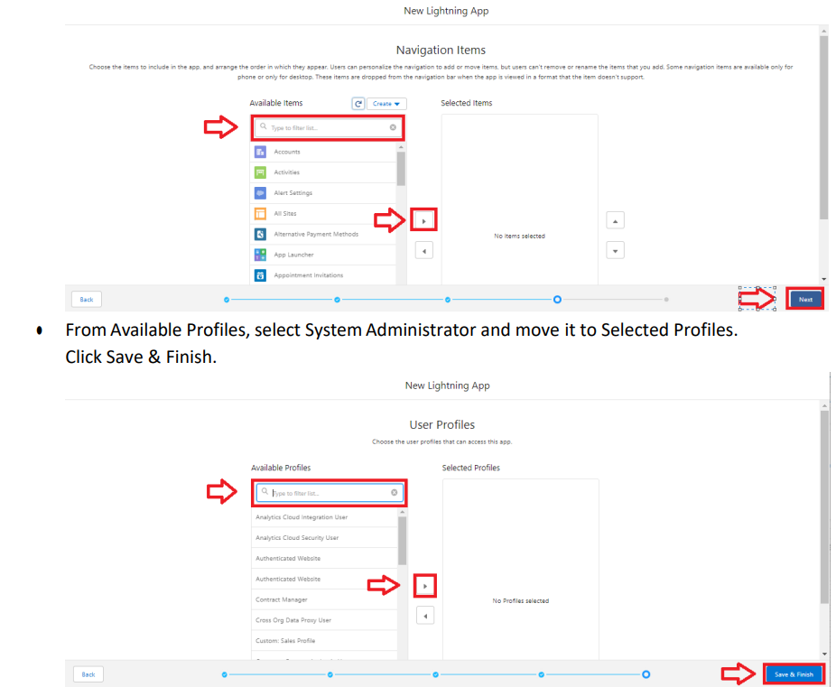

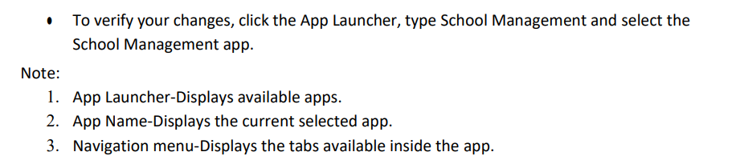

**Milestone 5 – Fields:**

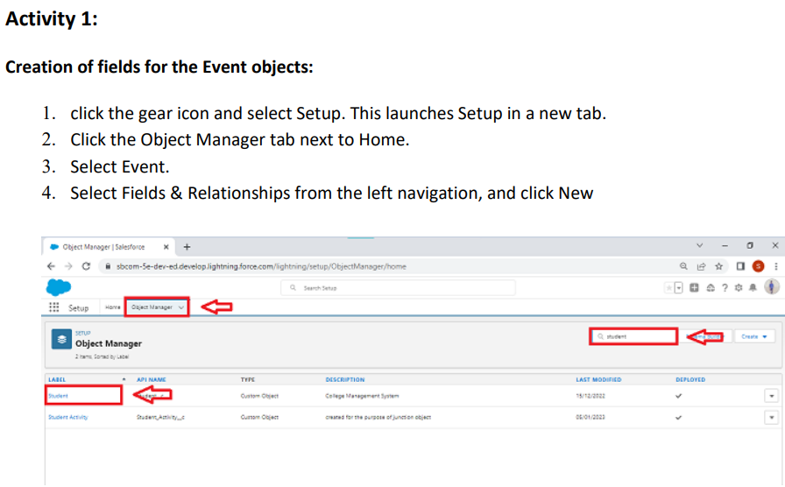

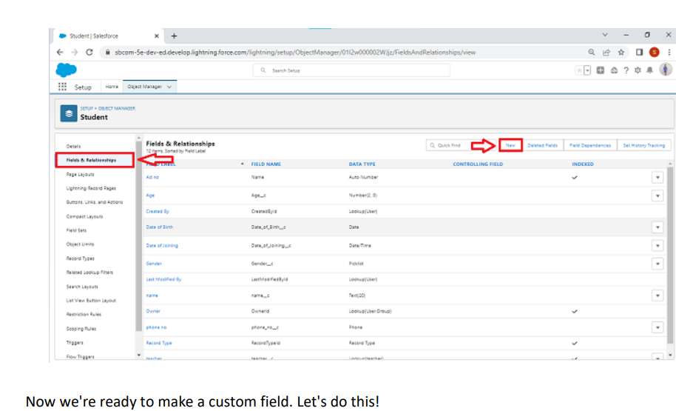

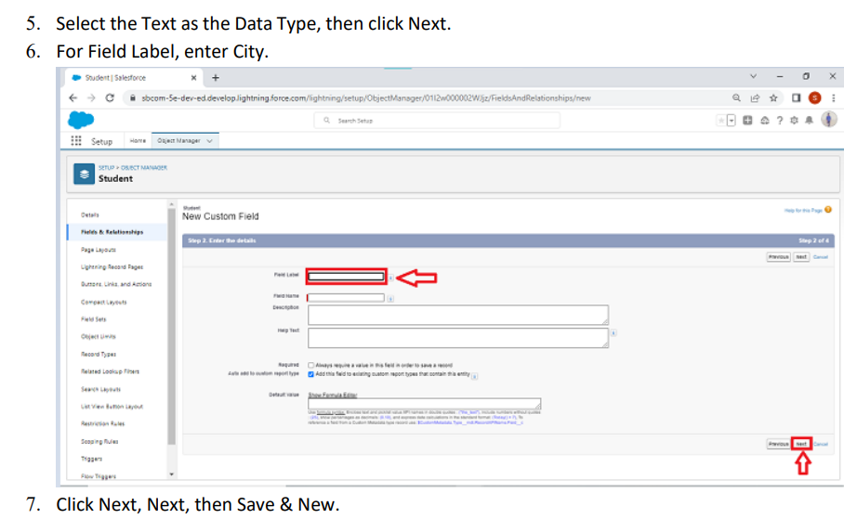

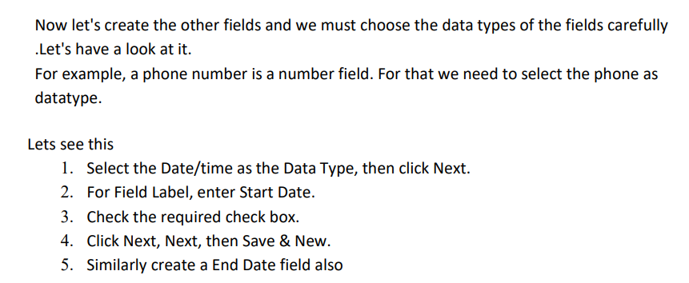

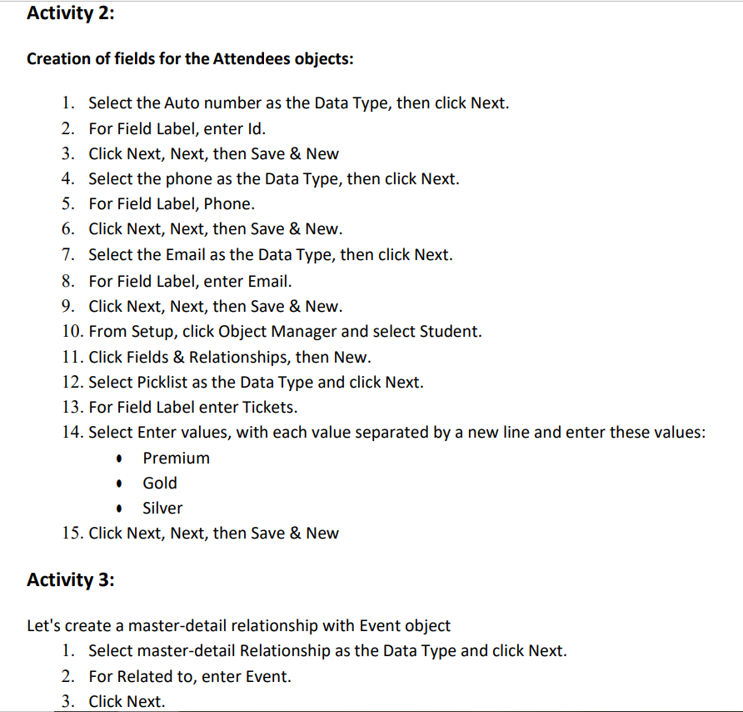



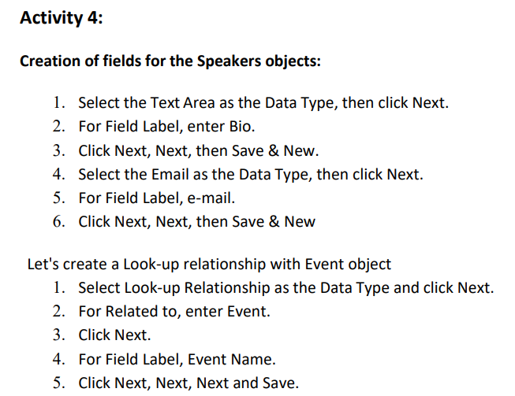

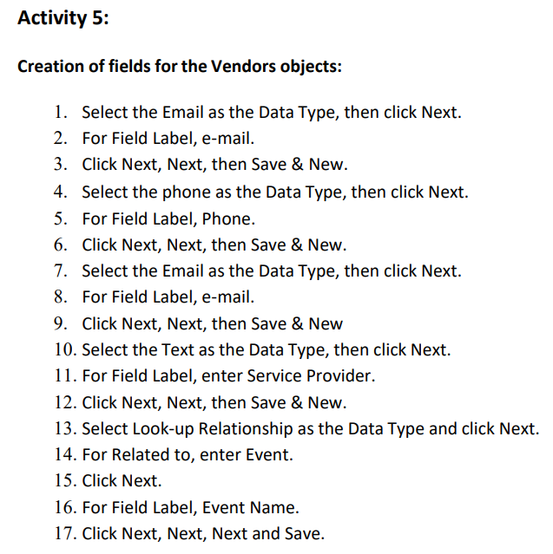

**Milestone 6 – Profile:**

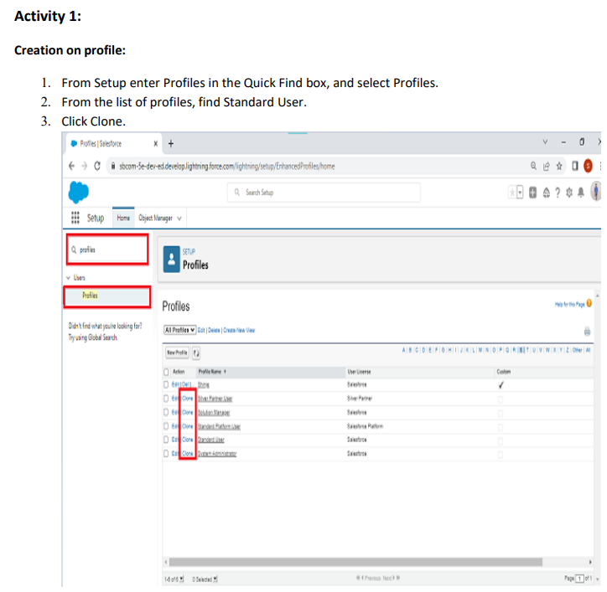

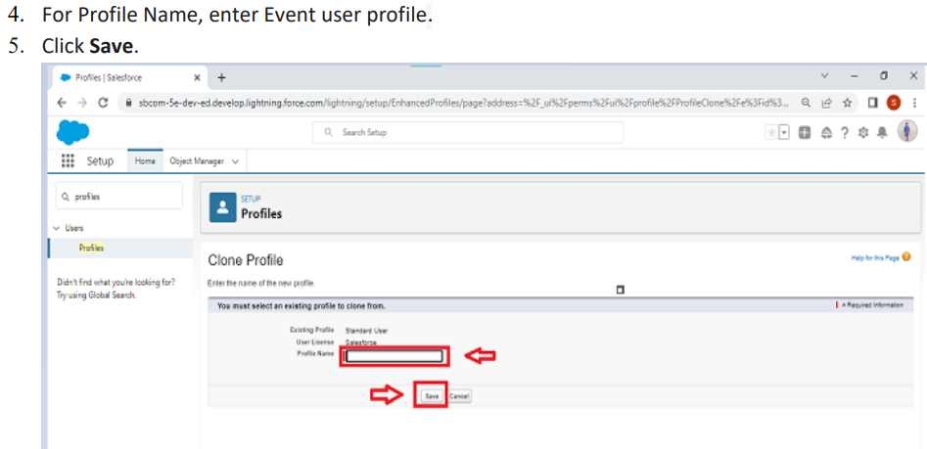

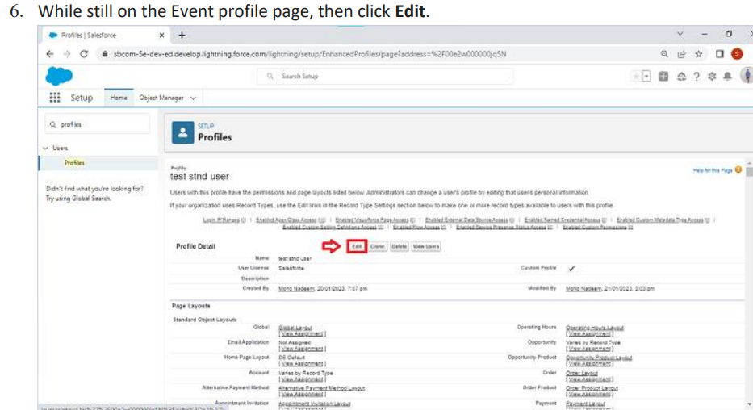

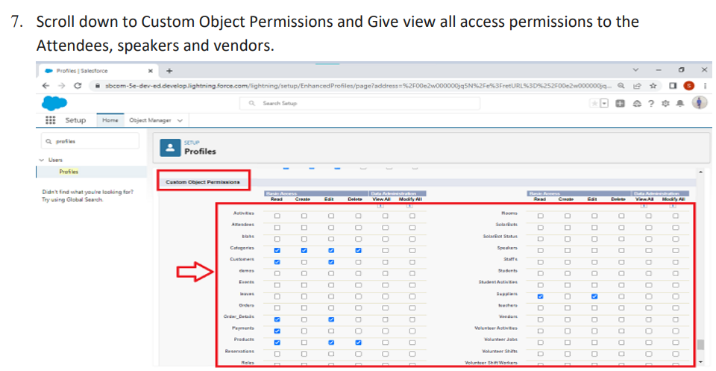

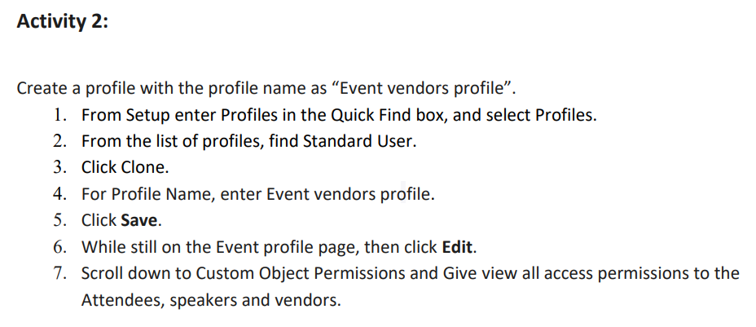

**Milestone 7 – User:**

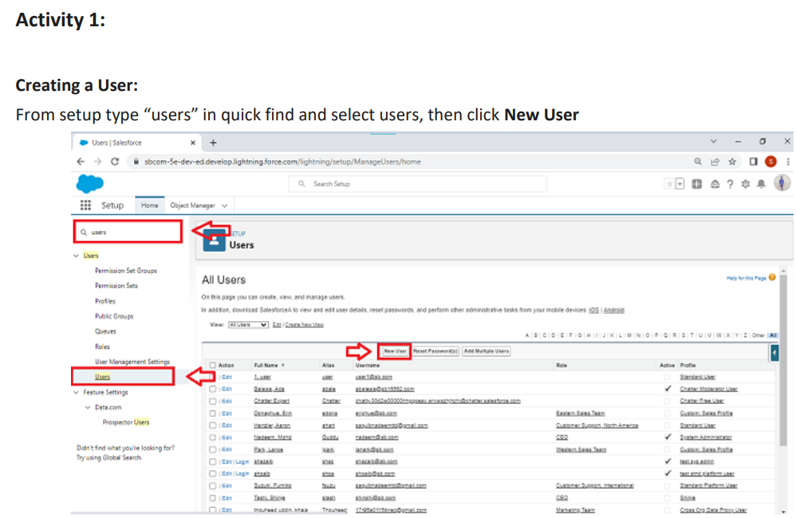

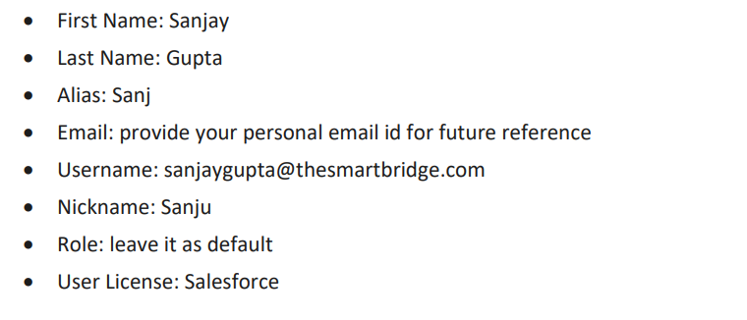

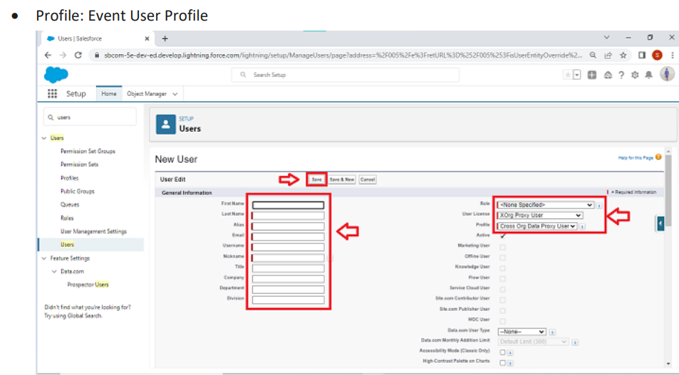

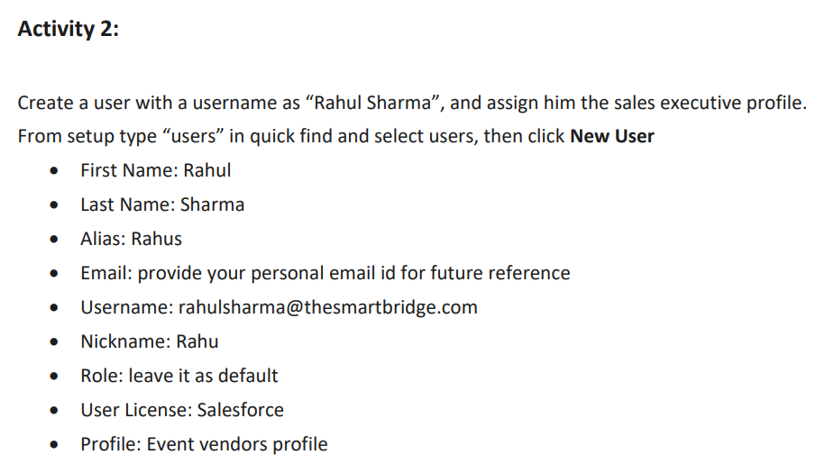

**Milestone 8 – Permission sets:**

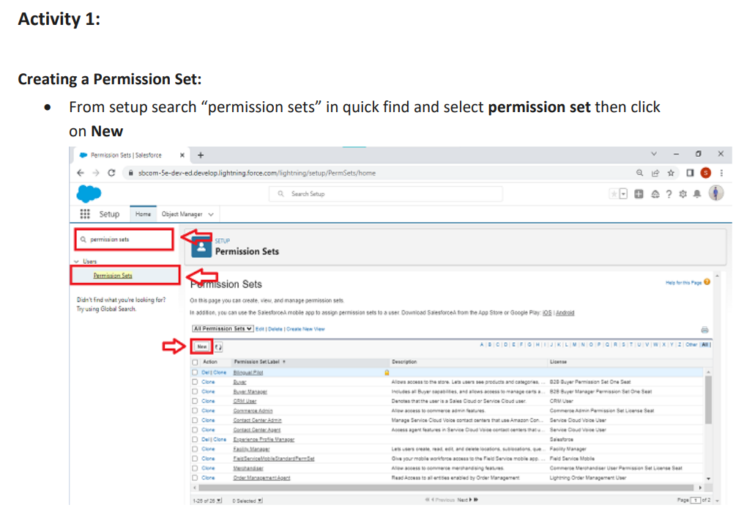

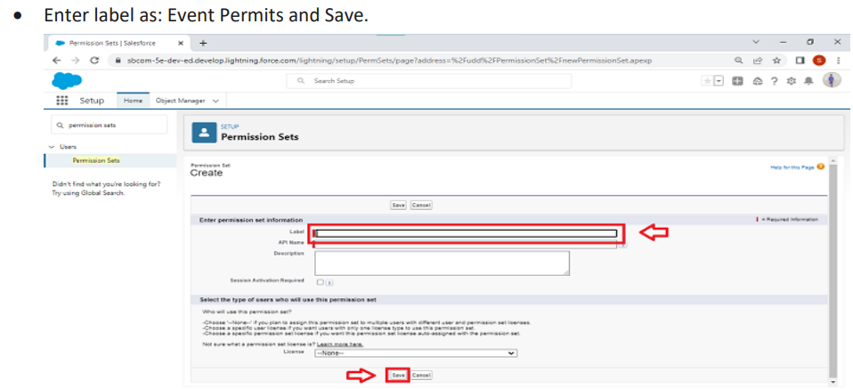

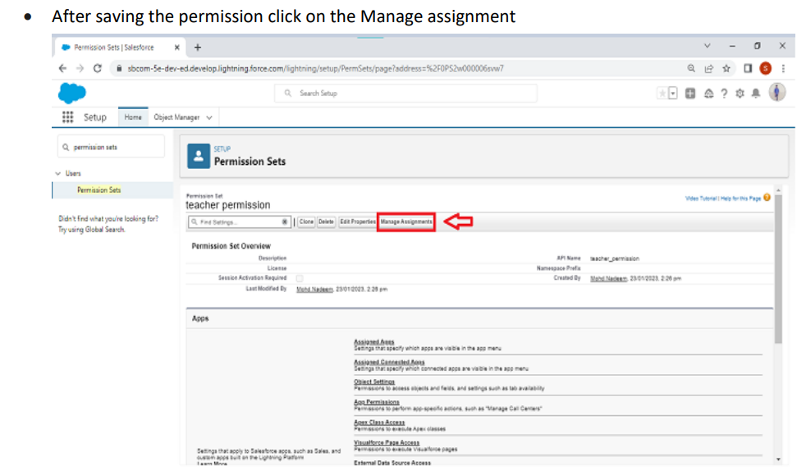

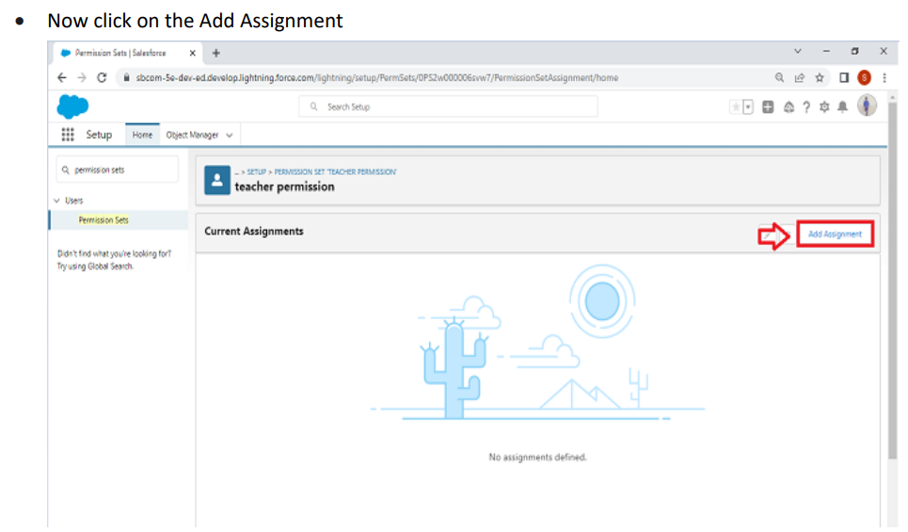

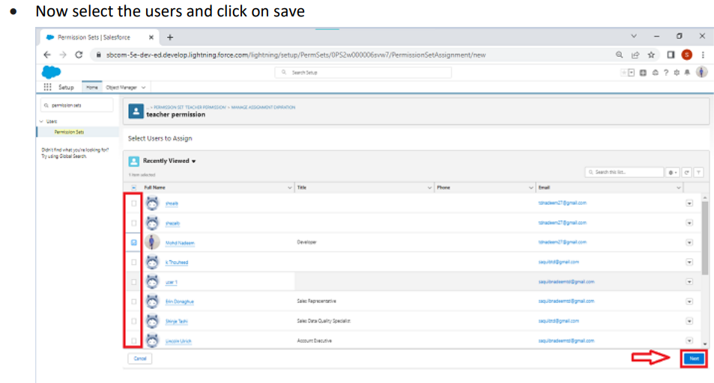

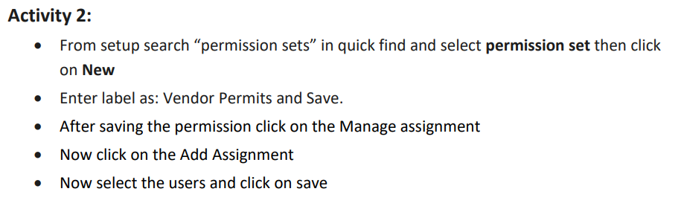

**Milestone 9 – Reports:**

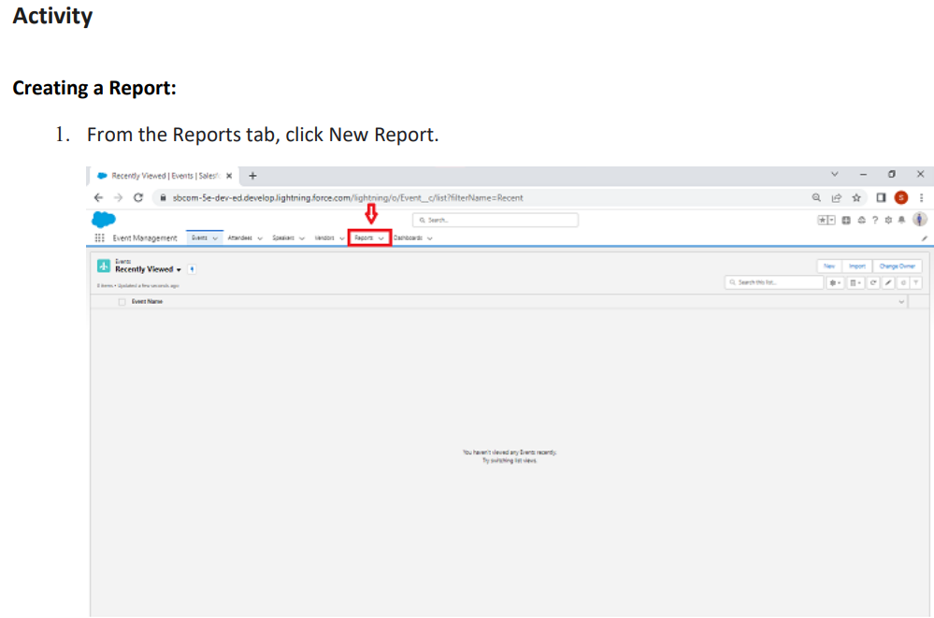

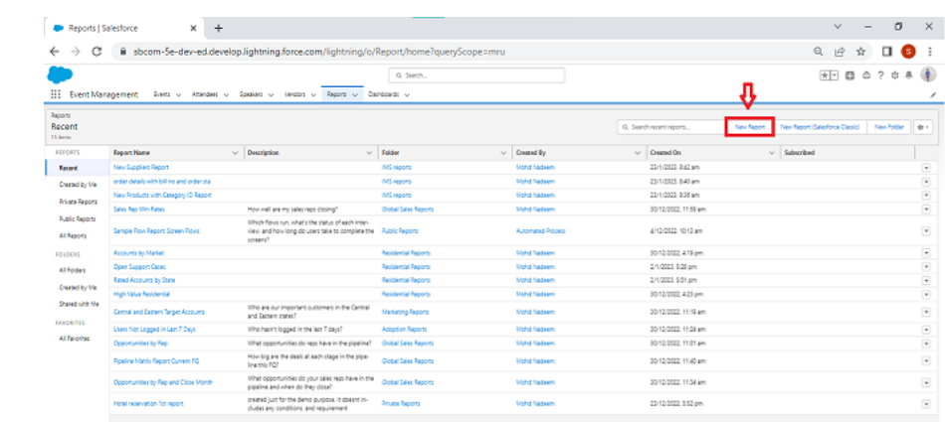

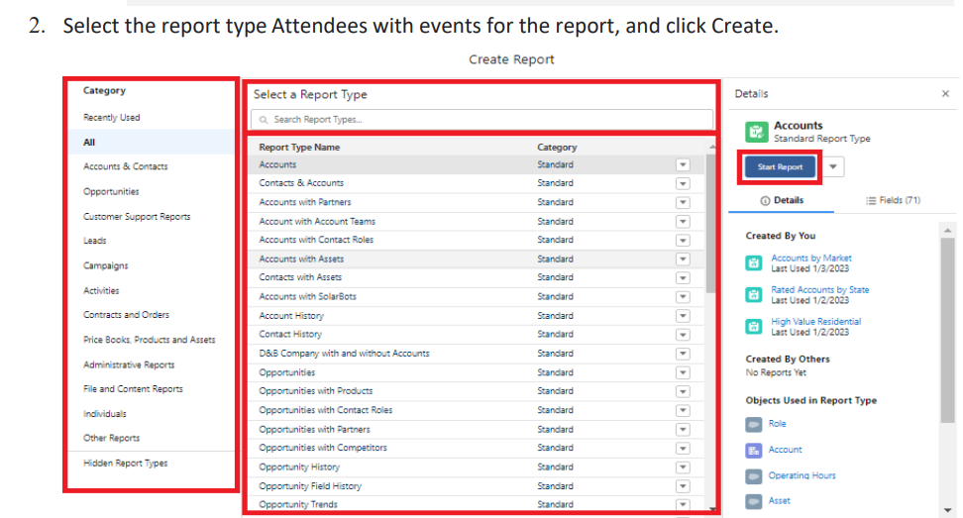

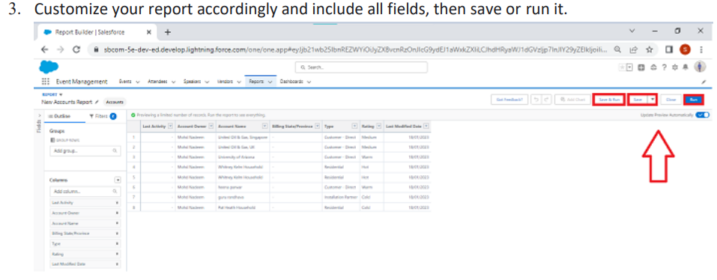

**4 Trailhead Profile Public URL**

Team Lead- https://trailblazer.me/id/janam55

Team Member 1- https://trailblazer.me/id/gowsk4

Team Member 2- https://trailblazer.me/id/isheerin

Team Member 3- https://trailblazer.me/id/ishwa95

**Advantages and Disadvantages**

* Opportunities for creativity
* Chance to work with diverse clients
* Collaborative work environment
* High projections for job growth
* Few educational requirements
* Unconventional work hours
* Time away from family and friends
* Ability to work on different events

**Applications**

An Event Management System (or Event Management Software) helps organizers plan, execute and report on events, driving success for their business.

1. Understand the issue. Whether it's an attendee or supplier bringing up the issue, make sure you fully understand it and all the ramifications before jumping in to solve it.
2. Create a plan.
3. If you're at fault, admit it.
4. Implement and follow up.

**Conclusion**

Event Management System is user friendly and cost effective system, it is customized with activities related to event management life-cycle. It provides a new edge to management industry.

It often involves the overall tone, structure, and goals of the event. An event concept sounds similar but is distinctly unique. By definition, an event concept is the event details and elements that make up the practical aspects of the event itself.

**Future scope**

Job growth for event planners is expected to be 11% between 2016 and 2026. Compared to 7% job growth across the economy, this indicates that the event planning industry is growing.

The career scope in event management is immense, as it involves managing, creating, and developing different events such as corporate events, parties, formal events, etc.